**ERD Resubmission**

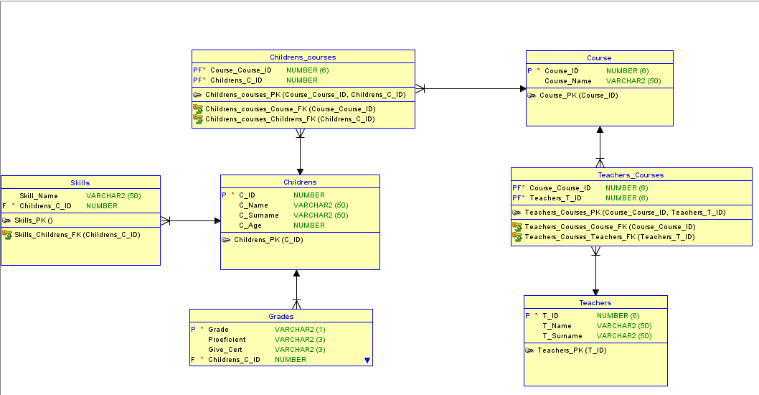

My thought process for creating the above ERD was as follows:

* Create a table for the children’s, including Children ID, name, surname and age. With the primary key of Children_ID so there is no repeated IDs.
  + A weak entity with two primary foreign keys, Course ID and Children ID.
* Another table for teachers where it had their Teacher ID, name, surname. With a primary key of Teacher_ID so there is no repeated IDs
  + A weak entity with two primary foreign keys, Course ID and Teachers ID.
* A table for Courses with the Course ID and name. With a primary key of Course ID so there is no repeated IDs
* A table for skills containing the skill’s . With a foreign key Children ID
* Lastly a grades table with grade, proficiency, give_cert. With a Primary key grade and a foreign key of Children ID